**FYP Mid Defense Template**

***Sukkur IBA University***

**Software Design Specification (SDS)**

For

[IoT Based Real time Patient Health Monitoring System]

Version [1.0]

[Team Members: Mashooque Ali & Saad Ishaq]

[Supervisor: Dr. Syed Asif Raza Shah]

Date of preparation

21/4/2021

|  |  |
| --- | --- |
| *Project Code* | *F17144* |
| *Supervisor* | *Dr. Syed Asif Raza Shah* |
| *Co-Supervisor* | *Mr. Nisar Ahmed Siddiqui* |
| *Project Manager* | *Mashooque Ali* |
| *Project Team* | *Saad Ishaq*  *Mashooque Ali* |
| *Submission Date* | *21/4/2021* |

**Table of Contents**

1 Introduction of Design Document 3

2 Entity Relationship Diagram (ERD) 4

3 Sequence Diagrams 4

4 Architecture Design Diagram 7

5 Database Diagram 8

6 Class Diagram 9

7 Interface Design 10

8 Test Cases 11

# Introduction of Design Document

When any system is developed, it contains documentation which helps the stakeholders, users, entrepreneurs, and business-related people to understand the main functionality and purpose of the system. To provide the better understandability sometimes we provide user manuals, tutorials and a document which contain the visualization of the complete system functionality. As we know, people learn and pick things faster if it is visualized. The main purpose of this document to show functionalities, features and working (internally and externally) of our final year project using different diagrams which will help the evaluators to understand all functionalities of our system. Moreover, in future if someone wish to extend the functionalities or add new features then he can easily do it.

This document contains the following diagrams and cases.

* Entity Relationship Diagram
* Sequence Diagrams
* Architecture Diagram
* Database Diagram
* Class Diagram
* Interface Diagram
* Test Cases (it is not a diagram).

# Entity Relationship Diagram (ERD)

“An entity is an article or segment of information. An entity is addressed as square shape in an ER diagram. For instance: In the accompanying ER diagram we have two elements Student and College, and these two elements have numerous to one relationship as numerous understudies concentrate in a solitary school.”

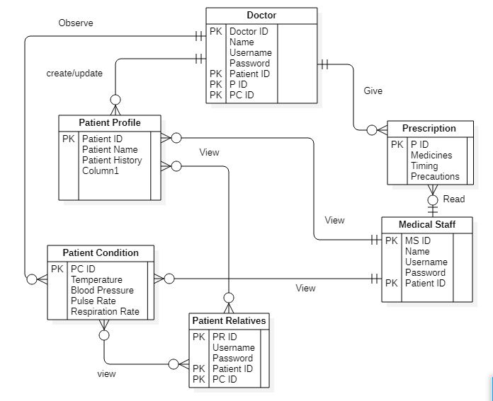

Figure 1 ER Diagram

# Sequence Diagrams

“A sequence diagram just portrays connection between objects in a successive request for example the request where these connections occur. We can likewise utilize the terms occasion diagrams or occasion situations to allude to a sequence diagram. Sequence diagrams depict how and in what request the items in a framework work.”

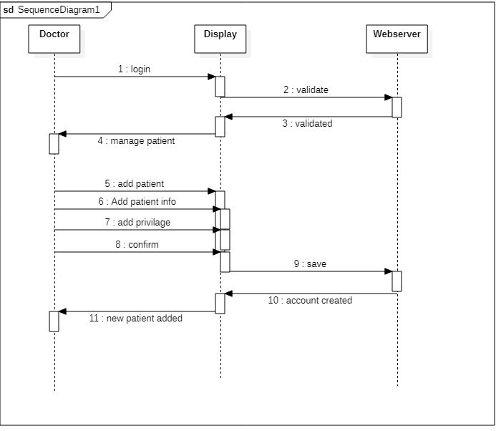

Figure Sequence Diagram of Doctor

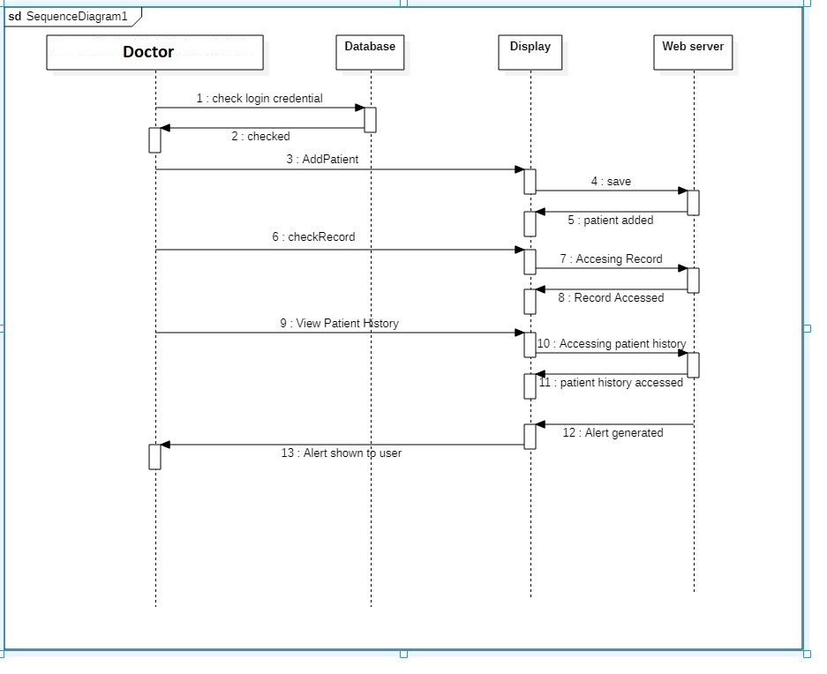

Figure Sequence Diagram Add Patient

# Architecture Design Diagram

“An architectural diagram is a diagram of a framework that is utilized to extract the general blueprint of the product framework and the connections, imperatives, and limits between segments. It is a significant device as it gives a general perspective on the actual sending of the product framework and its advancement guide.”

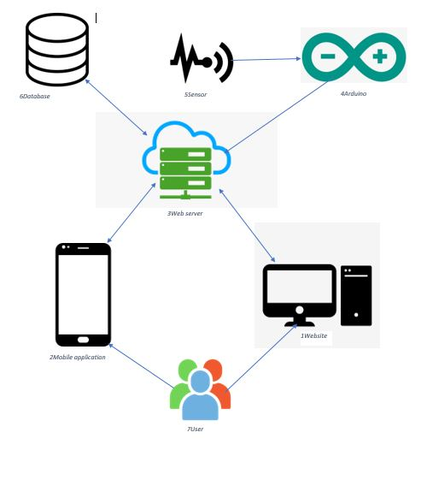

Figure Architecture Diagram

# Database Diagram

“Database diagrams graphically show the construction of the database. Utilizing database diagrams, you can make and alter tables, segments, connections, and keys. Also, you can alter lists and requirements.”

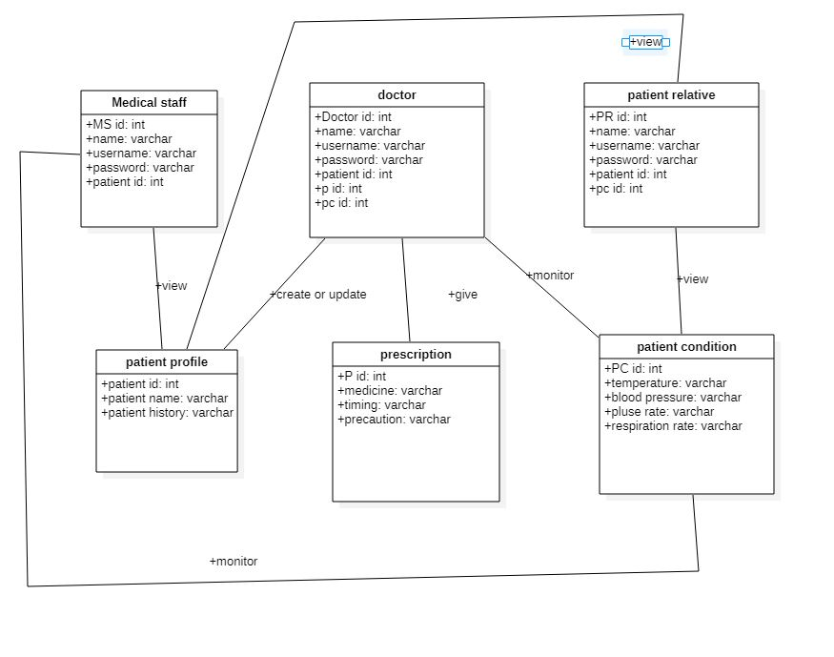

Figure Database Diagram

# Class Diagram

“The class diagram is the fundamental structure square of article arranged displaying. It is utilized for general reasonable demonstrating of the construction of the application, and for itemized displaying making an interpretation of the models into programming code. Class diagrams can likewise be utilized for information displaying.”

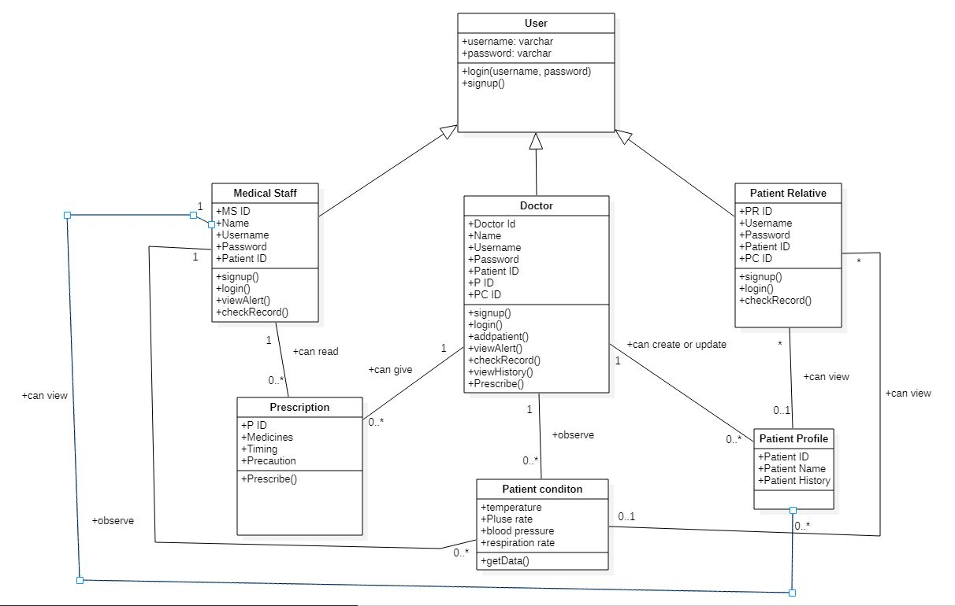

Figure Class Diagram

# Interface Design

“The interface block diagram is a conventional framework designing square and-line diagram addressing the sensible interfaces that associate parts inside a framework or framework portion.”

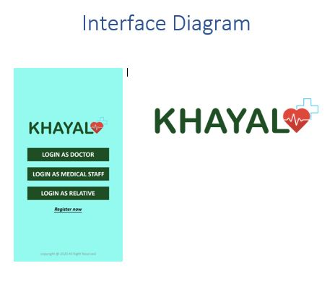

Figure Interface Diagram

# Test Cases

“Test Design is unpredictable archive portraying the testing cycle. It portrays a rundown of contributions for given programming that will give a bunch of anticipated yields.”

|  |  |  |  |  |
| --- | --- | --- | --- | --- |
| S/no. | Scenario | Test Step | Expected Result | Actual Outcome |
| 1 | Checking the patient data sent to the webserver. | Patient data is sent to the webserver at real time | Patient data is sent over webserver without any latency or hindrance | Patient data is successfully received at webserver. |
| 2 | Checking the patient data is accessed by the users | Patient data is shown on user side at real time | Patient data is received at user side without any latency or hindrance | Patient data is accessed at user side and now ready to be observed. |
| 3 | Checking the user’s login credentials. | User login through correct username and password | User uses the services of system application | User is successfully login to the system application |

Table Test Cases